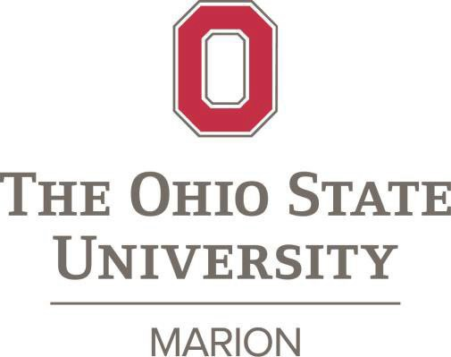

The Marion Staff Advisory Committee is now accepting nominations for the 2026 Ohio State Marion Outstanding Staff Award.

This award is presented annually to one Ohio State Marion staff member in recognition of exceptional accomplishments, leadership, and service to the campus within the past year.
Students, faculty, and staff are encouraged to nominate a deserving staff member for performance above and beyond traditional work assignments. Nominations from sources outside of the Ohio State community will not be accepted.

Nomination Criteria:
This award recipient will be selected on her/his merits and strengths that contribute to the overall success of
The Ohio State University at Marion. A candidate should meet at least one of the criteria listed below to be considered for this award:
- Enhance the quality of work life at Ohio State Marion in ways that make a significant difference for students, colleagues, and/or the community.
- Provide outstanding and ongoing excellence in service to staff, students, faculty, and/or the community.
- Distinguish themself by exhibiting outstanding work habits that set a positive example for others, consistently throughout their career at Ohio State
- Consistent demonstration of one or more of these additional university values:

  - Openness and Trust
  - Diversity in People and Ideas
  - Change and Innovation
  - Simplicity (Efficiency) in our Work
  - Empathy and Compassion
  - Leadership

Nomination Process:

- Nominations will be collected using Qualtrics https://go.osu.edu/2026outstandingstaff
- Submissions will be limited to 300 words and should include detailed and specific examples of excellence.
- Nominations will be reviewed and selected by the MSAC committee.
- Deadline Wednesday July 15th, 2026
The 2026 awardee will receive a $750 monetary award and recognition on a campus plaque honoring award recipients. The recipient’s nomination materials will also be sent to the Columbus campus for consideration for The Ohio State University Distinguished Staff Award. Previous recipients of the Distinguished Staff Award are ineligible for nomination.

Criteria for eligible staff member nominees:
Previous Awardees
2025 Ashley Marsh
2024 Amy Erickson
2023 Shellie Shirk
2022 Julie Prince
2021 Bryan Sickmiller
2020 Sharon Gattshall
2019 Leslie Beary
2018 Chris Trapp
2017 Joe Zhou
2016 Gary Iams
2015 Charles Rager
2014 Lynda Ross
2013 Cheri King
2012 Barbara Kaelber
2011 Karin Lanius
2010 Dan Aquino
2009 Carol Bowman
2008 Cathy McClain
- Part–time or full-time employees
- Classified Civil Service (CCS) or Administrative Professional (A&P)
- Minimum of five years continuous service with Ohio State Marion
- MSAC committee members are not eligible for this award.
- Past awardees of the Outstanding Staff Award are eligible after five years.

Current MSAC Members: Bryan Sickmiller, Dawn Hockensmith, Sara Teynor, Kelly Crum, Lisa Miller & Shellie Shirk

Ohio State Marion Outstanding Staff Award Application Rubric

Nominee’s Name:

For each criterion please checkmark a box (Excellence, Meets Requirements, Meets Some Requirements, or Does Not Meet Requirements) and leave comments.

Criteria | Excellence 3 |  | Meets Requirements 2 |  | Meets Some Requirements 1 | Does Not Meet Requirements 0 | Points Talley
Enhance the |  |  |  |  |  |  | 3 points possible
quality of work
life in ways that
made a
significant difference for
Colleagues, students or
customers?
Comments:
Provide |  |  |  |  |  |  | 3 points possible
outstanding and
ongoing
excellence in
service to
faculty, staff, students,
community
and/or other
customers?
Comments:
Distinguish |  |  |  |  |  |  | 3 points possible
her/himself by
exhibiting
outstanding work
habits that set a positive example
for others,
consistently
throughout
his/her career at
Ohio State?
Comments:
Consistently | Openness | Diversity in | Change & | Simplicity | Empathy and | Leadership | 6 points possible
demonstrate | and Trust | People | Innovation | (efficiency) | Compassion | Leadership | 6 points possible
one or more of  these additional university |  | and Ideas |  | in our Work |  | Leadership | 6 points possible
values |  |  |  |  |  | Leadership | 6 points possible
Comments on proposal:
Overall Rating. Check one of the following as your overall rating of the Nominee.
/15
Do the letters of support site specific examples of the accomplishments, contributions, service and the positive impact with the nominee’s own work unit and/or across the university? Yes / No
Additional Comment(s):

3/1/18

