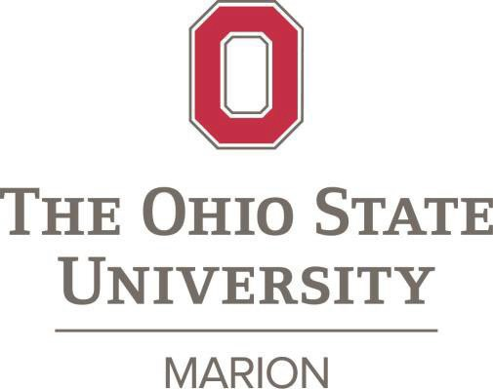

The Marion Staff Advisory Committee is now accepting nominations for the 2025 Ohio State University at Marion Outstanding Staff Award.

This award is presented annually to one Marion Campus staff member in recognition of exceptional accomplishments, leadership, and service to the campus within the past year.

Students, faculty, and staff are encouraged to nominate a deserving staff member for performance above and beyond traditional work assignments. **Nominations from sources outside of the Ohio State community will not be accepted.**

# Nomination Criteria:

This award recipient will be selected on her/his merits and strengths that contribute to the overall success of the Marion Campus. A candidate should meet at least one of the criteria listed below in order to be considered for this award:

* Enhance the quality of work life at Marion in ways that make a significant difference for students, colleagues, and/or the community.
* Provide outstanding and ongoing excellence in service to staff, students, faculty, and/or the community.
* Distinguish themself by exhibiting outstanding work habits that set a positive example for others, consistently throughout their career at Ohio State
* Consistent demonstration on one or more of these additional university values:
  + Openness and Trust
  + Diversity in People and Ideas
  + Change and Innovation
  + Simplicity (Efficiency) in our Work
  + Empathy and Compassion
  + Leadership

# Nomination Process:

* Nominations will be collected using Qualtrics <https://go.osu.edu/2025outstandingstaff>
* Submissions will be limited to 300 words and should include detailed and specific examples of excellence.
* Nominations will be reviewed and selected by the MSAC committee.
* Deadline Wednesday **October 31st, 2025**

The 2025 awardee will receive a $750 monetary award and recognition on a campus plaque honoring award recipients. The recipient’s nomination materials will also be sent to the Columbus campus for consideration for the OSU Distinguished Staff Award. Previous recipients of the Distinguished Staff Award are ineligible for nomination.

## Criteria for eligible staff member nominees:

Previous Awardees

2024 Amy Erickson

2023 Shellie Shirk

2022 Julie Prince

2021 Bryan Sickmiller

2020 Sharon Gattshall

2019 Leslie Beary

2018 Chris Trapp

2017 Joe Zhou

2016 Gary Iams

2015 Charles Rager

2014 Lynda Ross

2013 Cheri King

2012 Barbara Kaelber

2011 Karin Lanius

2010 Dan Aquino

2009 Carol Bowman

2008 Cathy McClain

* Part–time or full-time employees
* Classified Civil Service (CCS) or Administrative Professional (A&P)
* Currently employed by Ohio State Marion
* **Minimum of five years continuous** service with Ohio State Marion
* MSAC committee members are not eligible for this award.
* Past awardees of the Outstanding Staff Award are eligible after **five years**.

**Eligible Employees:**

|  |
| --- |
| Thomas Marshall |
| Ashley Marsh |
| Stacy Mayes |
| Cathy McClain |
| Michelle McKinniss |
| Bishun Pandey |
| Christian Peregrina |
| Wayne Rowe |
| Tiffiny Rye-Mccurdy |
| Lisa Salyer |
| Jessica Sturgill |
| Carolyn Thacker |
| Chris Trapp |
| Colleen Waddle |
| Gerald Willis |
| Pat Wood |
|  |
|  |
|  |

|  |
| --- |
| Jane Arnold |
| Deanna Bachtell |
| Leslie Beary |
| Leslie Beyer-Hermsen |
| Kevin Casteel |
| David Collins |
| Barb Congrove |
| Chris Crisler |
| Jade Elkins |
| Travis Elkins |
| Ellen Farrell |
| Sharon Gattshall |
| Cathy Gerber |
| Louis Hominga |
| Scott Hushour |
| Steven Keller |
| Marketa Lillard |
| John Maharry |
| Ronnie Marquis |
|  |

**Current MSAC Members**: Bryan Sickmiller, Dawn Hockensmith, Sara Teynor, Kelly Crum, Joe Zhou, Lisa Miller & Shellie Shirk

## Marion Outstanding Staff Award Application Rubric

Nominee’s Name:

For each criterion please checkmark a box (Excellence, Meets Requirements, Meets Some Requirements, or Does Not Meet Requirements) and leave comments.

|  |  |  |  |  |  |  |  |
| --- | --- | --- | --- | --- | --- | --- | --- |
| **Criteria** | **Excellence 3** | | **Meets Requirements 2** | | **Meets Some Requirements** 1 | **Does Not Meet Requirements 0** | **Points Talley** |
| **Enhance the** |  | |  | |  |  | 3 points possible |
| **quality of work** |
| **life in ways that** |
| **made a**  **significant difference for** |
| **Colleagues, students or** |
| **customers?** |
| Comments: | | | | | | | |
| Provide |  | |  | |  |  | 3 points possible |
| outstanding and |
| ongoing |
| excellence in |
| service to  faculty, staff, students, |
| community |
| and/or other |
| customers? |
| Comments: | | | | | | | |
| Distinguish |  | |  | |  |  | 3 points possible |
| her/himself by |
| exhibiting |
| outstanding work |
| habits that set a positive example |
| for others, |
| consistently |
| throughout |
| his/her career at |
| Ohio State? |
| Comments: | | | | | | | |
| Consistently | Openness | Diversity in | Change & | Simplicity | Empathy and | Leadership | 6 points possible |
| demonstrate | and Trust | People | Innovation | (efficiency) | Compassion |
| one or more of  these additional university |  | and Ideas |  | in our Work |  |
| values |  |  |  |  |  |
| Comments on proposal: | | | | | | | |

Overall Rating. Check one of the following as your overall rating of the Nominee.

/15

Do the letters of support site specific examples of the accomplishments, contributions, service and the positive impact with the nominee’s own work unit and/or across the university? Yes / No

Additional Comment(s):

3/1/18